
SUBMISSION OF TASK
NAME: OLOKESUSI ADEYEMI ENIOLA
TASK: Secure File Sharing System.
TOOLS: Python (Flask Framework), Cryptography Library, SQLite Database, Visual Studio Code, Miniconda (for environment setup), and MS Word (for reporting ).
DETAILS: In this task, I created a Secure File Sharing which enables users to securely upload and download files while maintaining data confidentiality, integrity, and effective key management. All files are encrypted using AES-256 in Galois Counter Mode (GCM) prior to storage and are safely decrypted when retrieved by authorized users.
The goal of the project was to replicate real-world data protection practices commonly used in industries such as healthcare, law, and enterprise environments, where strong encryption and controlled access are essential for safeguarding sensitive information.

Findings:
The system reliably handles file uploads, encrypts and stores them using AES encryption, and generates unique download links, demonstrating successful communication between the backend and frontend. The MASTER_KEY environment variable operates correctly, ensuring secure key management.

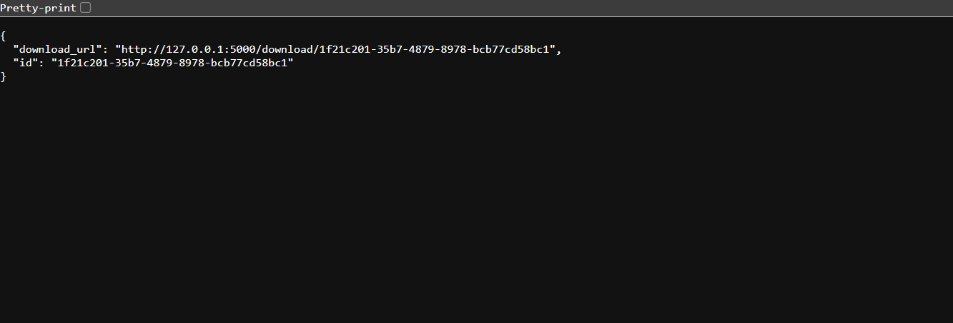

PROJECT WORKFLOW:
1. I developed a Flask-based web portal that enables users to upload and download files.
2. I integrated AES-GCM encryption to ensure both confidentiality and integrity of stored files.
3. I generated a dedicated 256-bit encryption key for each file and secured it using a system-wide MASTER_KEY.
4. I securely stored the encrypted files and their wrapped keys in local storage and an SQLite database.
5. I conducted end-to-end testing of the upload and download process to verify successful encryption and decryption.
6. I designed and implemented a user-friendly front-end interface using HTML and CSS.

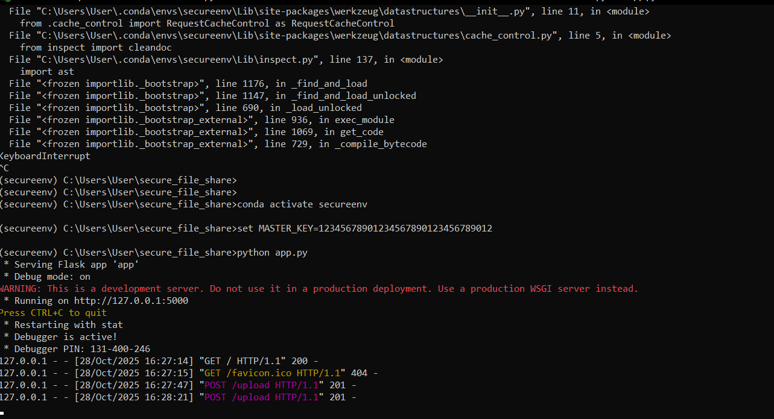

SECURITY DESIGN OVERVIEW:
Security Goal | Implementation
CONFIDENTIALITY | AES-GCM 256-bit encryption was used for all files before storage.
INTEGRITY | AES-GCM’s authentication tag ensures file tampering is detected.
KEY MANAGEMENT | MASTER_KEY stored as an environment variable; file keys are wrapped (encrypted) before storage.
SCALABILITY | Design supports integration with Key Management Services (KMS) or HSMs for enterprise-grade deployments.
TRANSPORT SECURITY
  HTTPS/TLS recommended for production environments.

IMPACT ASSESSMENT:
METRIC | DESCRIPTION
Data Confidentiality | High: even if the storage is compromised, the files remain encrypted
Data Integrity | High: tampered files cannot be decrypted without detection.
Key Security | Medium: secure under development setup, but requires KMS for production.
Usability | Moderate: system functional with scope for UI feedback improvements.

RECOMMENDATIONS:
Recommendations:
1. Enable HTTPS to ensure complete encryption of data during transmission.
2. Replace the environment-stored MASTER_KEY with a more secure, managed key solution such as AWS KMS or Azure Key Vault.
3. Introduce user authentication mechanisms (e.g., JWT or OAuth2) to enforce proper access control.
4. Implement audit logging to track all file upload and download activities.
5. Set up automated key rotation and routine verification of encrypted file backups.
Secure File Sharing System effectively showcases how strong encryption, key wrapping, and secure file handling can protect data both in transit and at rest. The main objectives secure encryption and decryption, robust key management, and functional backend operations were successfully achieved. Future enhancements will target expanding security measures, integrating user authentication, and improving the system’s user interface.

Skills Acquired:
1. Data Encryption and Cryptography (AES-GCM)
2. Web Application Development using Flask
3. Secure Key Management Practices
4. Backend Integration and Functional Testing
5. Security Architecture and Technical Documentation

